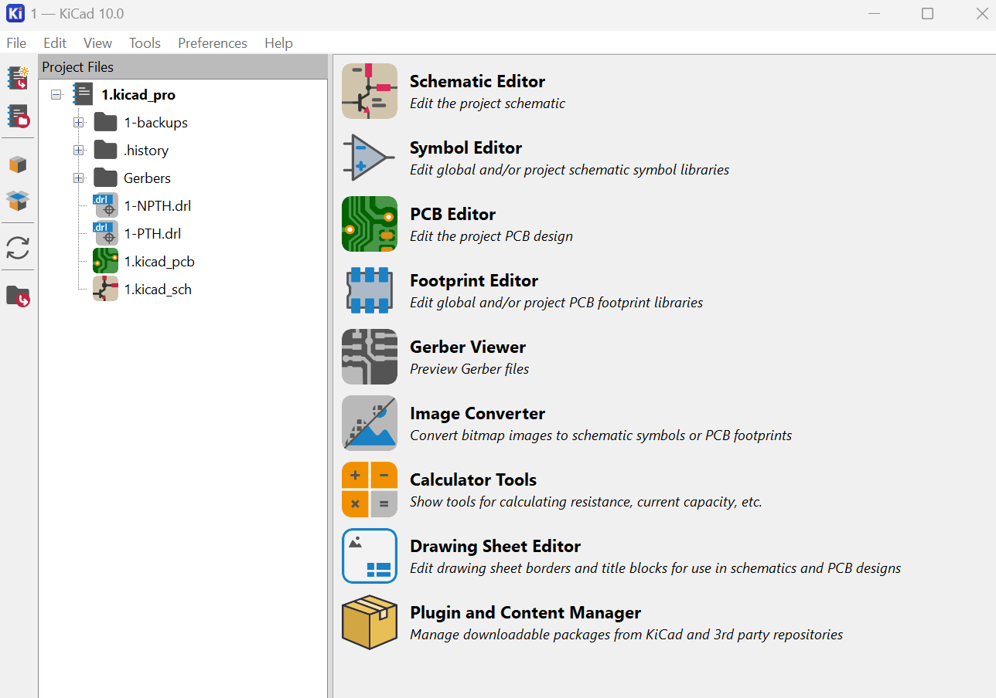
Open your Kicad and select “Plugin and Content Manager”

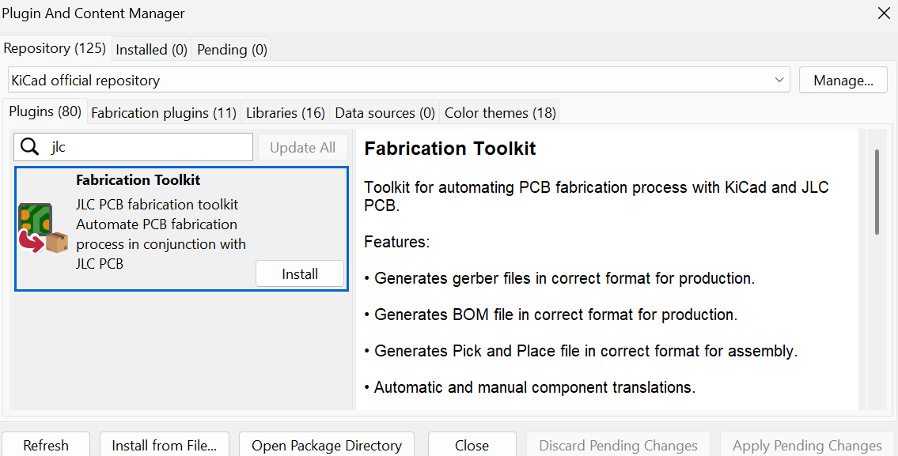
Search for and install “Fabrication Toolkit”

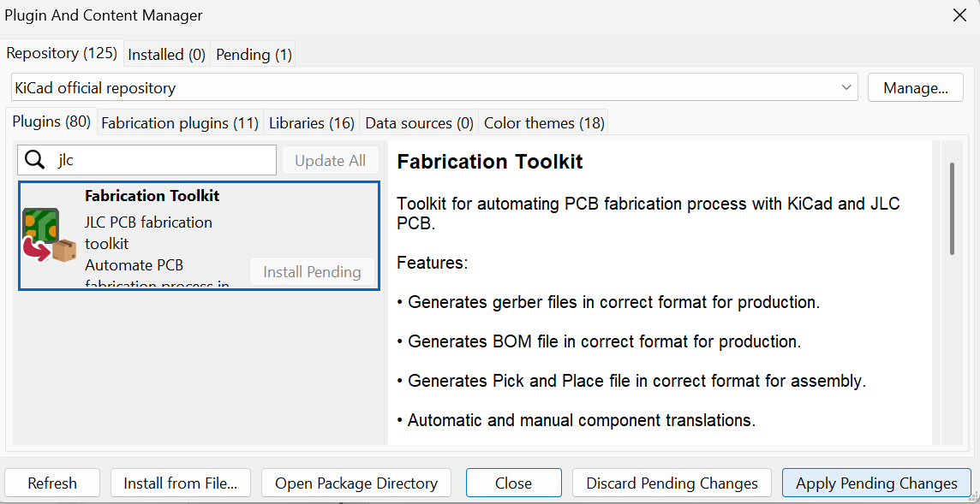
Hit “Apply Pending Changes”

Restart your Kicad. In your PCB editor you will now have an additional button
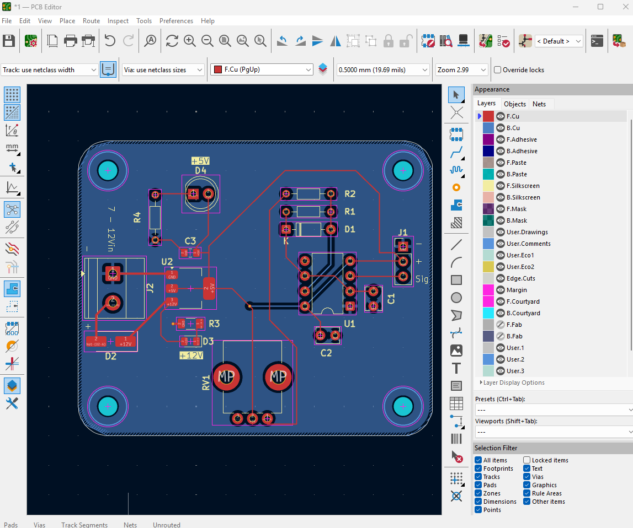
Name your files and hit “Generate”. These files are then ready to submit to JLCPCB.
